L5 – Data Transfer
Creating the PHP script
The PHP script must be built for it to be able to receive the data from the raspberry and send the data to our database.
The code simply takes a POST request, gets the data from it then it validates the data, once done and everything is correct it will send it to the database.
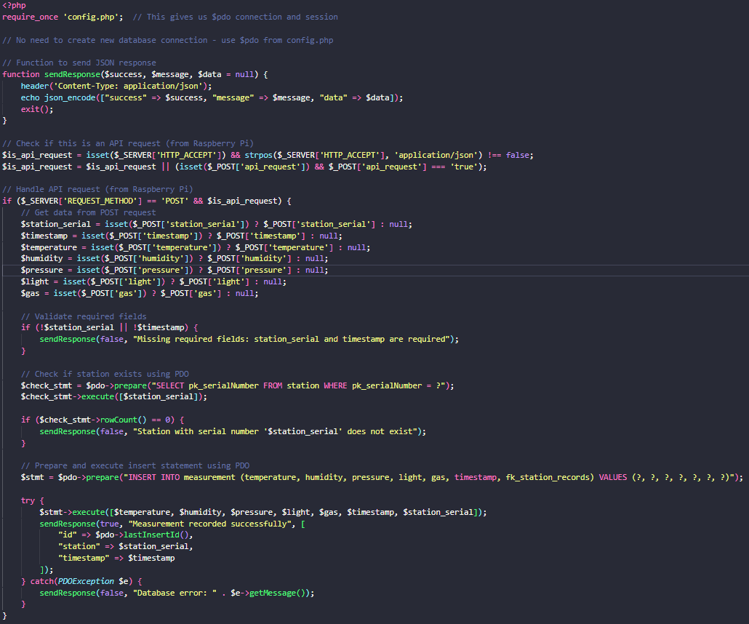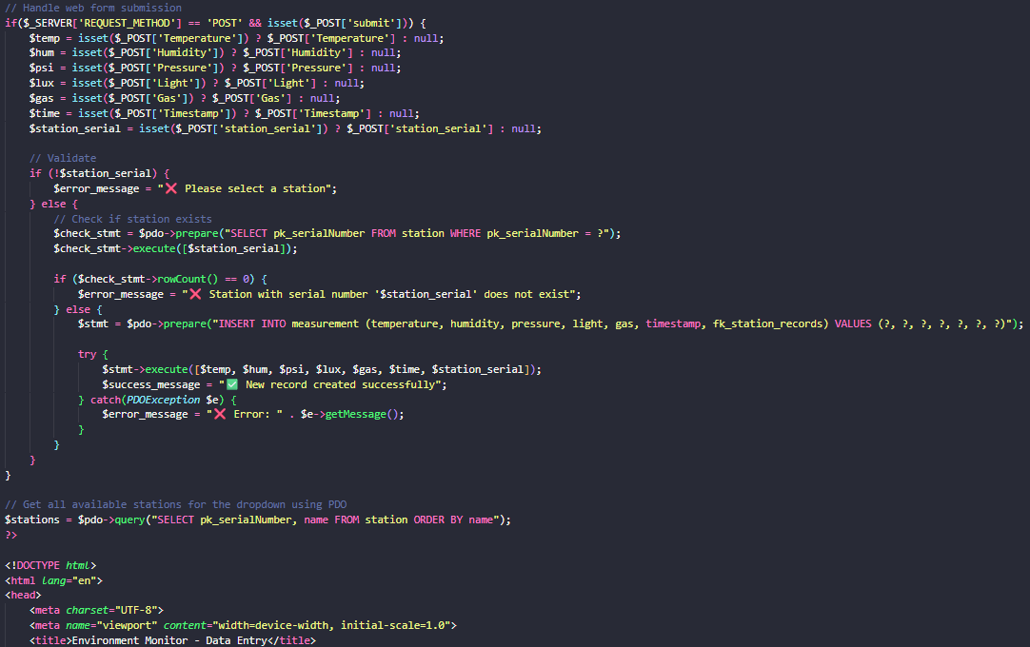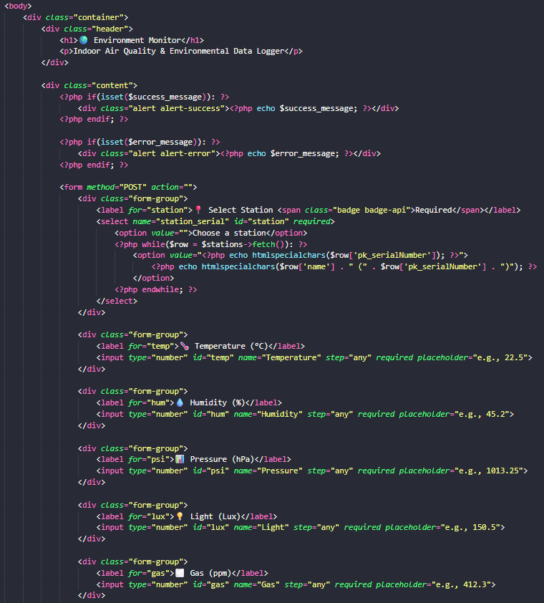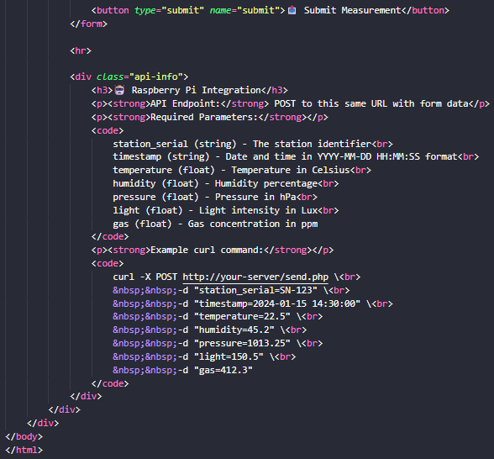

Changing the configuration file.
After creating the script we need to change the configuration file on our raspberry pi so that it has the right parameters to fnd our website and send the correct data.
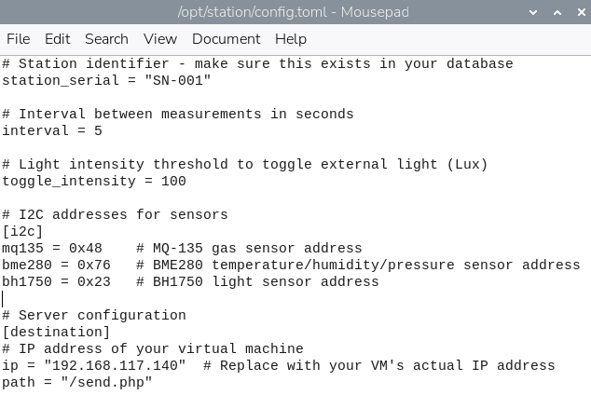

Issues
One issue that I encountered while working on this sprint is that we aren’t able to test it properly due to our VMware not having a bridged connection for some reason and since we weren’t able to bring our projects home, I couldn’t test it with my VMware.
